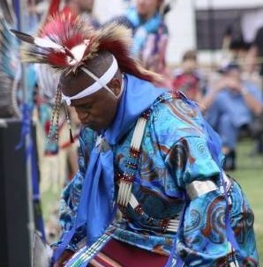
Southern Traditional -- Straight Dance

The Southern Straight dance has evolved from the warrior societies of the Hethuska. As such it is very precise in movement and clothing. The dancers are graceful yet powerful and this style is often referred to as the "Gentleman's dance" and the "Southern Tuxedo".
These titles are warranted, and the carefully matched clothing comes from the traditions of the Ponca, Kiowa, and Commanche. The most general regalia pieces are moccasins, leggings, bells, aprons, belt, ribbon shirt, bandoleers, vest, armbands, cuffs, dragger, and porcupine hair roach or otter turban. Some dancers wear breastplates, which can range in length from 6 inches to a couple feet. Dancers carry a fan, pipe bag, tail stick, or mirror board.

Fancy Feather Dance
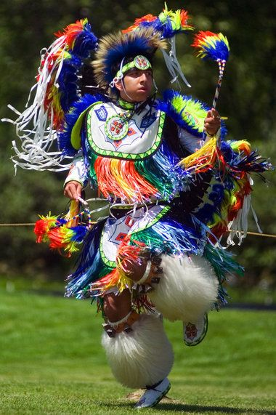
The origins of the Fancy Feather Dance are credited to the Ponca tribe. This dance originated as a war dance in the Hethuska society of Oklahoma but has developed into a popular powwow and contest style for all tribes.
The modern fancy dancer wears two bustles made with hackles and bright colored tapes to add flash and color to the clothes. Often complete sets of beadwork are seen, including harnesses, capes, aprons, side-tabs and belt, cuffs, moccasins, and headbands. Beaded rosettes may also be included as center-pieces for the bustles. Above the moccasins the dancer wears large angora goat hides that come to the knee. Here they are fastened with sheep bells and decorated bands. The dancer usually wears knee-length aprons in front and back, both fringed with ribbon. Side tabs are also worn; these can be beaded or have ribbon work and are also fringed. The cape covers the chest and back. Hackle bustles may be worn on each arm at the bicep, and beaded cuffs may be worn on the wrist. The dancer wears a headband with beaded medallions and a porcupine hair roach. The spreader usually includes a rocker and most dancers wear two Eagle feathers. The entire set is made to match in color and pattern. The dancer also carries hand items which can include mirror boards, fans, and whip-sticks.

Northern Traditional Dance

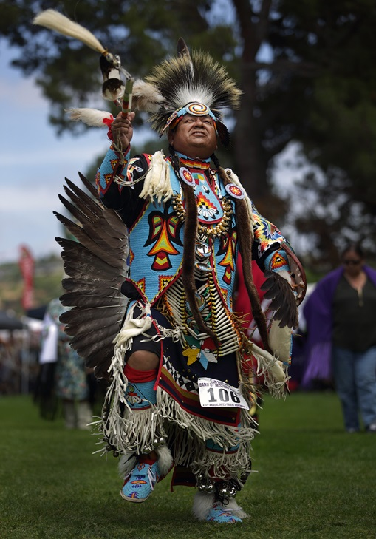
The Contemporary and Northern Traditional Dance has evolved from the "Old-Time Sioux" style of dance. This originated on the reservations and has since spread into the powwow culture. It is still primarily a Northern style of dance. Northern Traditional dancers generally have a tribal focus for their beadwork, while Contemporary traditional dancers generally have more widely used geometric designs in their beadwork.
The traditional dancer is most easily recognized by the large round bustle worn on the back. These are generally made of eagle or goose feathers, but can also be made from turkey. Beaded pieces include moccasins, knee bands, aprons, side tabs and belt, cape or vest, necktie, chocker, epaulets, armbands, cuffs, and a bustle rosette. The dancer wears a porcupine hair roach with two feathers in a socket spreader. The dancer carries hand items such as a dance stick, medicine wheel, pipe bag, mirror board, and wing fan.

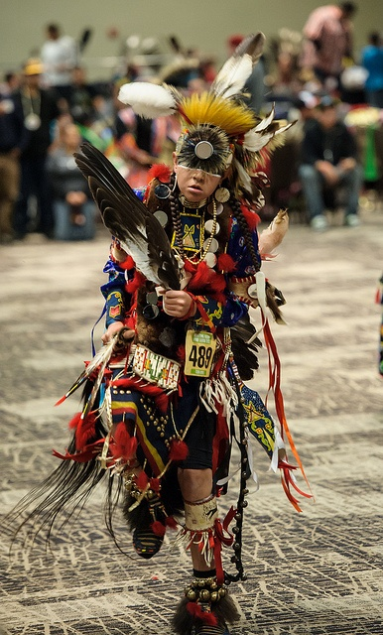
The Old-Style Dance

What has been termed "Old-Style" is a re-creation of the Old-Time Sioux war dances. The regalia and steps are similar to those war dancers used during the reservation period.
This style is often used to categorize any tribal specific dance regalia or period regalia, and as a result the clothing can vary widely. Within the powwow culture, these are all considered Men's Traditional. Unlike the Northern Traditional dancer, the bustle is arranged in a tight, messy circular pattern, and is referred to as a “messy bustle.” Often dancers will wear bone breastplates, otter capes, and long strands of sleigh bells. Porcupine quill work is also seen in various cuffs, moccasins, pipebags and even breastplates. Lazy stitch beadwork can also be present on moccasins, vests, cuffs, and bull’s tails for roaches. Because of the age of the dance, more natural materials are used.

Grass Dance
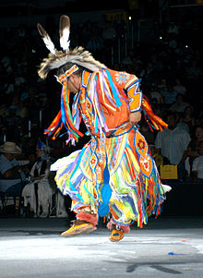
The origins of the Grass Dance are widely debated, and several tribes have been credited with starting and spreading this dance. Most sources agree however, that the dance originated when the young men were asked to clear the fields for camp setup and for dances. The young men would dance down the tall grass and even pull some and stuff it into their belts. The modern Grass Dance regalia is made so that as the dancer moves, he mimics these old ways and the swaying fringe mimics the grass.
Beadwork can include moccasins, aprons, side tabs and belt, cuffs, armbands, headband, harness, and even cape. The dancer will wear pants and a shirt underneath these pieces, both of which may have ribbon work attached. The cuffs, cape, aprons, side tabs, and knees are all fringed with yarn or ribbon. The dancer wears a porcupine hair roach and a spreader with feathers or antennae with fluffs at the end. He carries items such as fans, mirror boards, whip-sticks, scarves, and rarely a dance stick.

Praire Chicken Dance
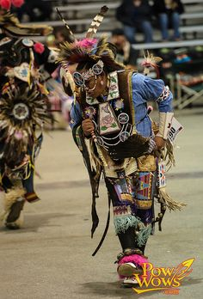
“The Prairie Chicken Dance (or Chicken Dance) is one of the oldest forms of Native American dancing. There is some controversy over the origin of this dance, however, what can be agreed upon though, is that it was a sacred dance (of the Kiitoki Society), given to a Warrior by the spirit of a Prairie Chicken.
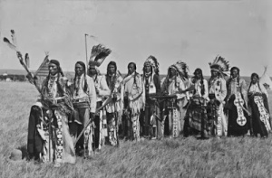
Long, long ago, legend tells of a Warrior who was out hunting. As he was searching for food he came upon a thumping noise that resonated through the earth. The man’s curiosity impelled him to search further and follow the strange vibrations traveling up through him body. As he walked closer, the sound became louder and more intense, and when he reached to area where the noise was resonating from he saw a group of Prairie Chickens dancing in the long grass.
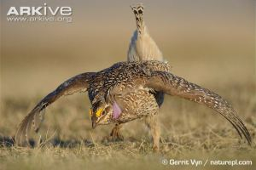
So, as the Warrior watches one particular Prairie Chicken doing his dance, he lifts up his bow, aims and kills it. The Warrior takes the Prairie Chicken back to his camp and the women cook it up and everyone feasts on it. As the night progresses and everyone is full, a clam befalls the camp and all settle down to sleep for the night. The Warrior quickly falls into slumber and as he is in a deep sleep, the Prairie Chicken’s spirit appears to him in his dream. “Why did you kill me?” , he said to the Warrior, “for I was doing a sacred dance for my great Nation”. The Warrior replied with great appreciation for the Prairie Chicken’s sacrifice, “My family was hungry and needed to eat”. The Prairie Chicken understood the Warrior’s needs and accepted his humble reply by honoring him and teaching him the sacred dance of the Prairie Chicken Nation. As the sun rose in the sky, and the Warrior awoke from his dream, he told his people about the Prairie Chicken’s visit and the gift he gave to the People.

OH.... Here's a great video of the Men's Chicken Dance https://www.youtube.com/watch?v=lVlbyh0CjPE
Thanks for your follow everyone
Melvin War Eagle”
https://www.melvinwareagle.com/blogs/native-american-chicken-dance/116478595-native-american-chicken-dance

